**SOUTHERN RIVER COLLEGE**

**Human Biology**

**Unit 3**

**TASK 2 - Validation**

**Reflexes Investigation (5%)**

**TYPE:** Investigation Validation: **/40** Scientific report: **/10  
CONTENT:** Nervous systemTotal: **/50**

When the gun goes off to start an Olympic race in Tokyo in 2020, you won’t see any hesitation on the part of the athlete before they leave the start blocks.

In sprinting, a sport reliant on solely speed, even the shortest of pauses could be the difference between winning and losing. In the men’s 100m sprit in the 2012 London Olympics, bronze medal winner Justin Gatlin, ran 9.79 seconds while the fourth-place finisher Tyson Gay ran 9.80 seconds.

1. **Identify what a reflex is and describe the importance of this response. (2 marks)**

________________________________________________________________________________

________________________________________________________________________________

________________________________________________________________________________

________________________________________________________________________________

1. **Describe a basic spinal reflex arc. (5 marks)**

________________________________________________________________________________

________________________________________________________________________________

________________________________________________________________________________

________________________________________________________________________________

________________________________________________________________________________

________________________________________________________________________________

________________________________________________________________________________

________________________________________________________________________________

1. **Label A to D of the diagram below. (4 marks)**

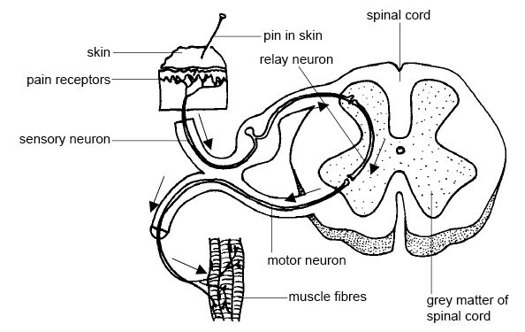

D)

C)

B)

A)

The auditory reaction times of 18 to 25 year old 100m Men’s World Champions were measured and compared to male non-athlete reaction times.

1. **Complete the following**

**(1 mark)**

**Aim:** ___________________________________________________________________________

________________________________________________________________________________

**(2 marks)**

**Hypothesis:** _____________________________________________________________________

________________________________________________________________________________

**Variables: (4 marks)**

Independent: _____________________________________________________________________

Dependent: ______________________________________________________________________

Controlled: ______________________________________________________________________

_______________________________________________________________________________  
  
_______________________________________________________________________________

1. **Complete the results tables below: (5 marks)**

|  |  |  |  |
| --- | --- | --- | --- |
| Participating Athletes | Trial 1 (milliseconds) | Trial 2 (milliseconds) |  |
| 1 | 149 | 155 |  |
| 2 | 130 | 181 |  |
| 3 | 129 | 135 |  |
|  | | |  |

|  |  |  |  |
| --- | --- | --- | --- |
| Participating Non- Athletes | Trial 1 (milliseconds) | Trial 2 (milliseconds) |  |
| 1 | 255 | 267 |  |
| 2 | 343 | 352 |  |
| 3 | 289 | 297 |  |
|  | | |  |

1. **Are there any outliers in this data? List them and provide a possible explanation for this. (2 marks)**

________________________________________________________________________________

________________________________________________________________________________

________________________________________________________________________________  
  
________________________________________________________________________________

1. **Graph this data on the graph paper provided. (5 marks)**
2. **Provide a brief description of these results. (2 marks)**

________________________________________________________________________________

________________________________________________________________________________

________________________________________________________________________________  
  
________________________________________________________________________________

________________________________________________________________________________

1. **Write a conclusion for these results. (2 marks)**

________________________________________________________________________________

________________________________________________________________________________

________________________________________________________________________________

________________________________________________________________________________

________________________________________________________________________________

________________________________________________________________________________  
  
________________________________________________________________________________

1. **Was this investigation valid and reliable? How could this be improved? (6 marks)**

________________________________________________________________________________  
  
________________________________________________________________________________

________________________________________________________________________________

________________________________________________________________________________

________________________________________________________________________________

________________________________________________________________________________

________________________________________________________________________________

________________________________________________________________________________

________________________________________________________________________________

________________________________________________________________________________

________________________________________________________________________________

________________________________________________________________________________

________________________________________________________________________________

________________________________________________________________________________